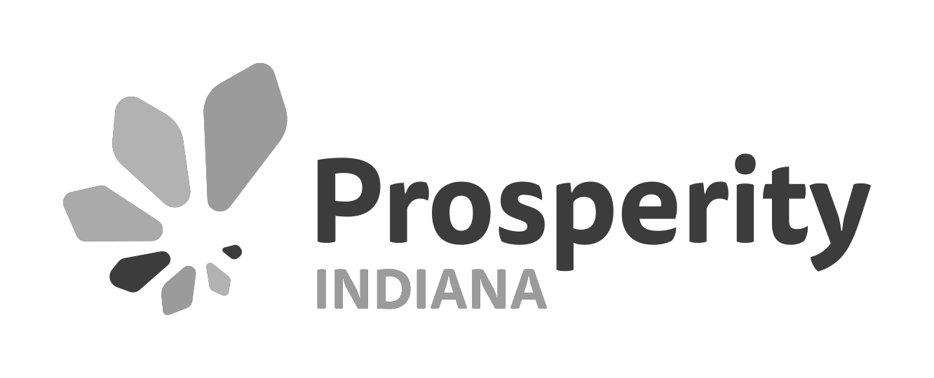

COVID-19's Impact on Your Organization

- Please identify your organization type.
Unit of Government
Human Services Provider
CDC/Nonprofit Affordable Housing Developer Financial Institution
Community Development Financial Institution Private Developer
Funder
Association
Other (please specify)

- Please estimate the level of impact COVID-19 is having currently on the programs, services, or general operations of your organization.
Little to no impact Minor impact
Moderate impact High impact

- Please estimate the level of impact COVID-19 is anticipated to have on the programs, services, or general operations of your organization.
Little to no impact Minor impact
Moderate impact High impact

- If your organization is anticipating or experiencing a decrease in revenue due to COVID-19, please share the estimated dollar amount ($).

- If your organization is anticipating or experiencing a decrease in revenue due to COVID-19, please share the estimated percentage (%) this loss represents of the total annual revenue.

- If your organization is anticipating or experiencing a decrease in revenue due to COVID-19, please share specific examples of what this loss means for your organization (services, staff, etc.).

- If your organization is anticipating or experiencing an increase in revenue due to COVID-19, please share the estimated dollar amount ($).

- If your organization is anticipating or experiencing an increase in revenue due to COVID-19, please share the estimated percentage (%) this increase represents of the total annual revenue.

- If your organization is anticipating or experiencing an increase in revenue due to COVID-19, please share specific examples of what this increase means for your organization (services, staff, etc.).

- If your organization has contract and/or grant dollars that are at risk, if specific delivery targets are not achieved within a certain period, please share. In particular, share the dollar amount and/or percentage of your overall operating budget that is at risk (estimates are fine, but please be as specific as possible).

- Which of the following impacts has your organization experienced or anticipates experiencing? (Check all that apply)
Cancellation of programs or events

Disruption of service to clients and communities

Disruption of supplies or services provided by partners and/or vendors Increased or sustained staff and volunteer absences
Staff layoffs or furloughs or reduced programming

Increase demand for services/requests for assistance from clients and communities Budgetary implications due to the strained economy
Other (please specify)

- Has your organization responded, or does it anticipate responding, to the spread of the coronavirus in any of the following ways? (Check all that apply)
Rescheduling or cancelling programs and events

Changing in-person events to virtual events using video conferencing services Revisiting or implementing remote work policies
Revisiting or updating sick leave policies

Encouraging employees who feel sick to stay at home

Encouraging proper hygiene, hand washing, and protection practices to reduce the spread of COVID-19 Increased cleaning and sanitizing of surfaces and providing products in your facility
Staying informed via news, other media, updates from the CDC and State of Indiana Sharing COVID-19 related guidance and updates with stakeholders
Other (please specify)

- What would your organization like donors or funders to know about the impact of COVID-19 on your organization and its programs or operations?

- What would your organization like government officials to know about the impact of COVID-19 on your organization and its programs or operations?

- What training and resources from Prosperity Indiana and peers would be most helpful to your organization? Please be as specific as possible.

- What is your organization's annual operating budget?
Under $250,000
$250,000 - $499,999 $500,000 - $999,999 $1,000,000 - $4,999,999 $5,000,000 - $9,999,999
$10,000,000 - $24,999,999
$25,000,000 or more

- How many months of cash reserves does your organization have on hand?
Less than 1 month 1 - 3 months
4 - 6 months
7 - 9 months
10+ months

- What is your organization doing differently in response to COVID-19, including new methods of service delivery?

- What resources or advice can you recommend to other nonprofits to assist them in adapting?

- Anything else that we should know or you would like to share? (Include additional information that would be helpful for funders or policymakers to understand.)

- Please share your contact information. (Optional)

Name

Organization

Address

Address 2

City/Town

State/Province ZIP/Postal Code
-- select state --
Email Address

Phone Number

- If you provided your contact information, may we share your organization's story with attribution?
Yes, you can share our story.
No, please keep our response anonymous.

