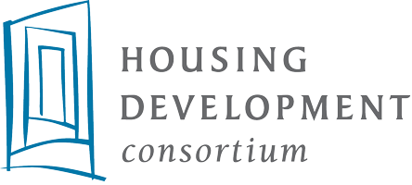
Member Survey for COVID-19 Response – March 2020

Q1. First and Last Name
Q2. Email
Q3. Name of Organization
Q4. Please select the role that primarily describes your organization (you will have the option to answer questions related to the other roles later).
- Affordable Housing Owners/Operators
- Affordable Housing Developers
- Other Affordable Housing Partners
For Affordable Housing Owners/Operators:
Q5. What is your greatest concern(s) related to the ongoing operation of your housing?
Q6. What is your greatest concern(s) related to providing service to your residents?
Q7. What do you need most right now?
Q8. How could your elected officials (local, State and Federal) assist your efforts?
Q9. What do you see to be your greatest long-term challenge(s) if the COVID-19 issue persists for 6 months to a year?
Q10. Please select the next role section you would like to complete.
For Affordable Housing Developers:
Q11. What are your greatest concerns related to your project development work?
Q12. What do you need most right now?
Q13. How could your elected officials (Local, State and Federal) assist your efforts?
Q14. What do you see to be your greatest long-term challenge(s) if the COVID-19 issue persists for 6 months to a year?
Q15. Please select the next role section you would like to complete.
For Other Affordable Housing Partners:
Q16. What are your greatest concerns related to your day-to-day operations?
Q17. What do you need most right now?
Q18. How could your elected officials (Local, State and Federal) assist your efforts?
Q19. What do you see to be your greatest long-term challenge(s) if the COVID-19 issue persists for 6 months to a year?

